**AIM:** Implement VLAN Configuration.

PRACTICAL: 7

# THEORY:

**VLAN-** VLAN is Virtual Local Area Network that can connect multiple devices and machines in a single network, without having to place the devices in same geographical location. . In a technical sense, a segment is separated from the rest of the LAN by a bridge, router, or switch, and is typically used for a particular department.

# TOPOLOGY:

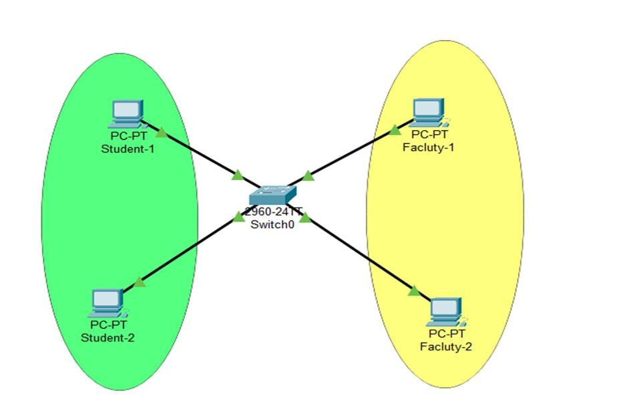

**Commands:**

* 1. First, we have to go to switch and we have to enable configurations and we can see there all ports will be in default VLAN

## Commands:

To enable switch: enable

To enable configuration: configure terminal To see the ports vlan status: show vlan

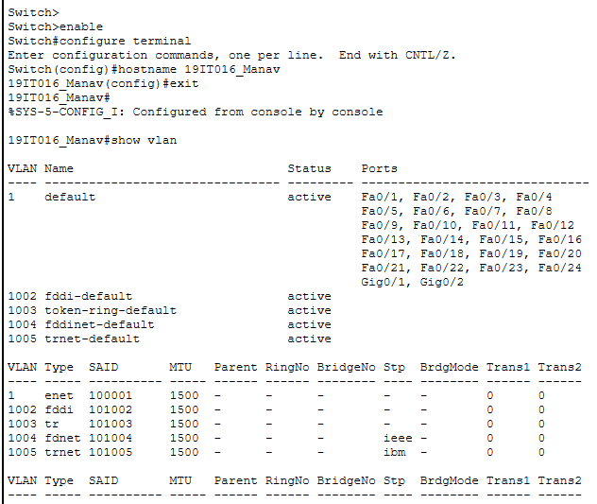

* 1. Now we will add two vlan as 10 for student and vlan 20 for faculty

## Commands:

vlan 10 name student vlan 20 name faculty

## Show vlans

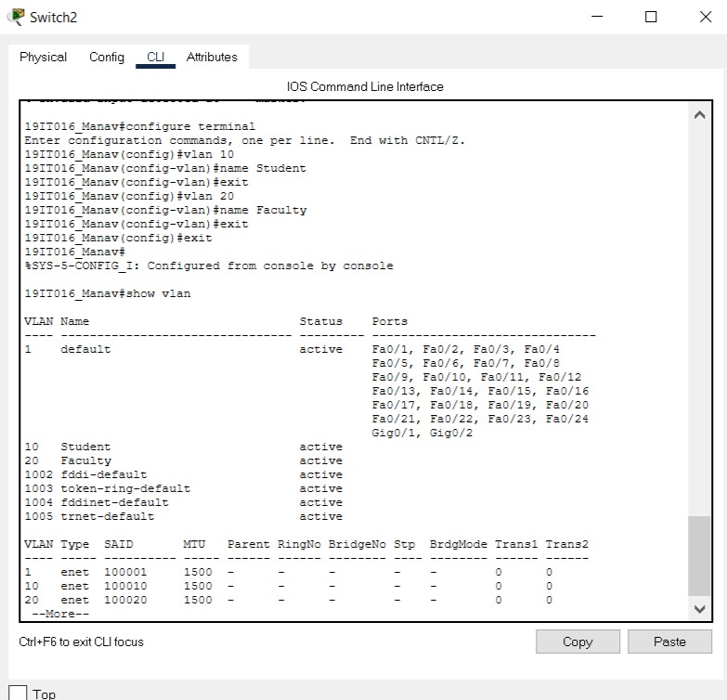

* 1. Now we have to change access of port 0/1 and 0/4 to Student and port 0/2 and 0/3 to the faculty

## Command:

inteface fastethernet 0/1 switchport mode access switchport access vlan 10 exit

inteface fastethernet 0/4 switchport mode access switchport access vlan 10 exit

inteface fastethernet 0/2 switchport mode access switchport access vlan 20 exit

inteface fastethernet 0/3 switchport mode access switchport access vlan 20 exit

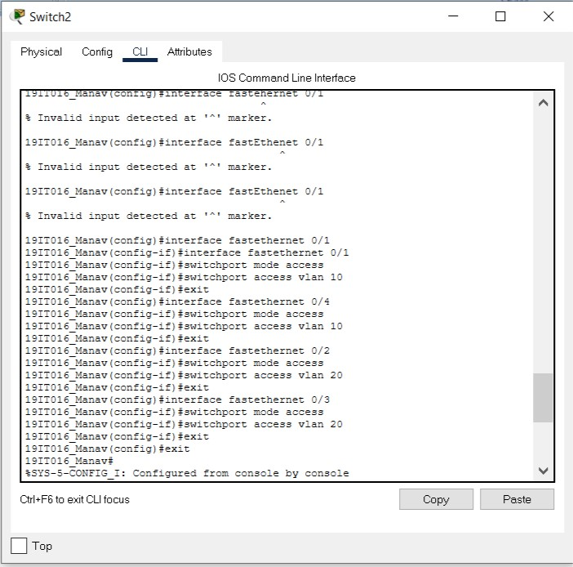

* 1. Now we can see port status using show vlan

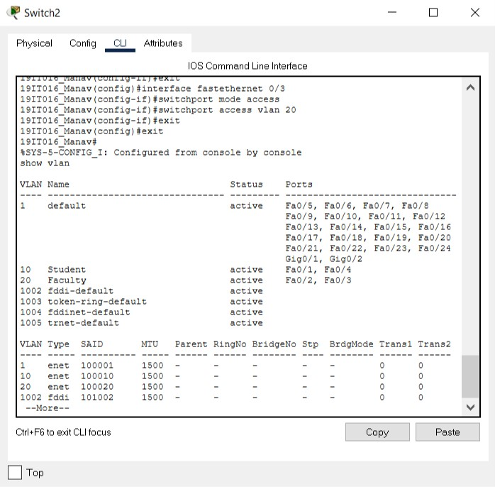

# OUPUTS:

Here we can see that Student_1 and Student_2 can able to communicate and faculty_1 and faculty_2 can able to communicate and Student and Faculty cannot able to communicate.

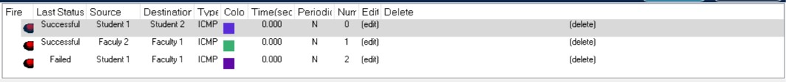

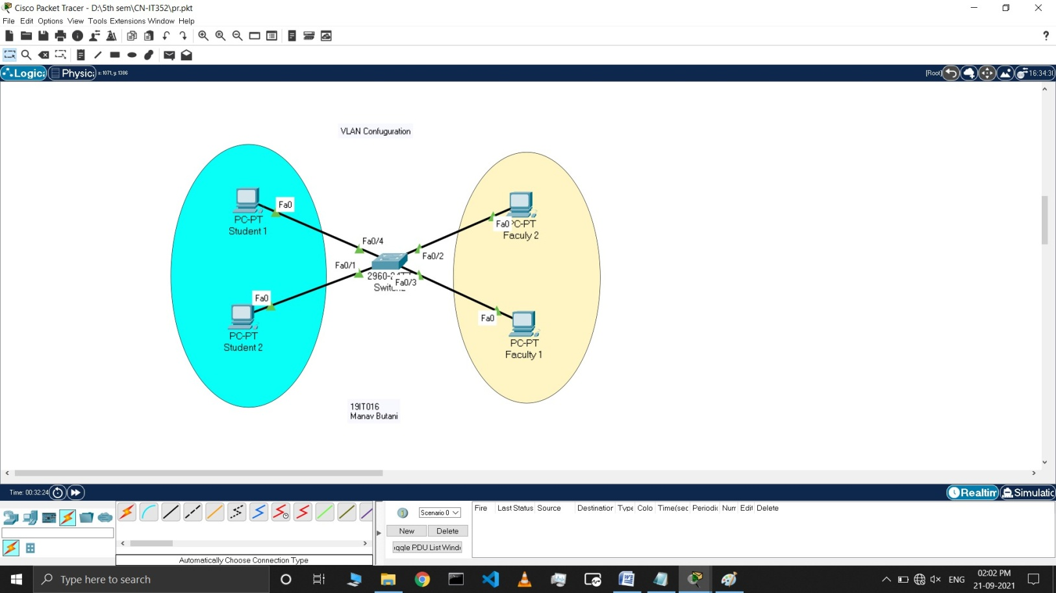

# LATEST APPLICATIONS:

* performance –The network traffic is full of broadcast and multicast. VLAN reduces the need to send such traffic to unnecessary destinations.
* formation of virtual groups – As there are different departments in every organization namely sales, finance etc., VLANs can be very useful in order to group the devices logically according to their departments.
* security – In the same network, sensitive data can be broadcast which can be accessed by the outsider but by creating VLAN, we can control broadcast domains, set up firewalls, restrict access. Also, VLANs can be used to inform the network manager of an intrusion. Hence, VLANs greatly enhance network security.
* The Application use of this VLAN is used in college and Multi National Companies, where specific communication between the employees and faculty to students is to be done.

# LEARNING OUTCOME:

In this practical W have learned about what is VLAN and how to create VLAN in Realtime time topology implementation to create virtual local area network to set, Limits of communication between two system.